Customer churn and retention analysis
Prepared by Mila Tshemese | Telco customer data set

- Executive Summary
About one in four customers left the company. This report looks at who is leaving, how long customers stay and what the business can do about i t. Contract type is the strongest signal. Customers on month-to-month contracts are 55% of the base but make up about 89% of all churners. Churn is also highest in the first 6 months among fiber optic and electronic check customers. The recommendations in section 6 focus on moving customers to longer contracts and improving the first 6 months and reviewing fiber optic and payment options.

- Data and cleaning
The dataset has one row per customer, with 21 columns covering demographics, services, contract billing and whatever the customer churned. There were no duplicate customer IDs and no blank cells. I made these changes on a copy of the original sheet:
- TotalChanges was stored as text. I converted it to numbers. 11 customers had a blank value; all of them have a tenure of 0 months, so i set these to 0.\
- SeniorCitizen was coded 0/1, so i recorded it to No/Yes to match the other columns.
- Churn_Flag is a new 1/0 column (1=churned), so churn rate can be calculated as an average.
- Tenure_Bamd is a new column grouping tenure into 0-6, 7-12, 13-24, 25-48 and 49-72 moths.
I checked the cleaning by confirming 7043 rows and an overall churn rate of 26.5%.
- Churn and retention
Overall churn is 26.5% (1,869 of 7,043 customers). The average tenure of customers who churned is about 18 months, compared with about 38 months for customers who stayed.
Churn falls sharply as tenure grows. It is 52.9% in the first six months and drops to 9.5% for customers with more than four years. About 56% of all churners leave within their first 12 months, so retention is mostly decided early.

Segment | Group | Churn Rate
Contract | Month-to-month | 42.7%
 | One year | 11.3%
 | Two year | 2.8%
Segment | Group | Churn Rate
Tenure | 0-6 months | 52.9%
 | 7-12 months | 35.9%
 | 13-24 months | 28.7%
 | 25-48 months | 20.4%
 | 49-72 months | 9.5%
Internet Service | Fiber optic | 41.9%
 | DSL | 19.0%
 | No internet service | 7.4%
Payment method | Electronic check | 45.3%
 | Mailed check | 19.1%
 | Bank transfer (automatic) | 16.7%
 | Credit card (automatic) | 15.2%

- Which customers churn most
- Contract: month-to-month customers churn at 42.7% compared with 11.3% on one year and 2.8% on 2-year contracts. That is roughly 15 times the churn of two-year customers.
- Internet service fiber optic customers churn 41.9% more than double DSL at 19.0%
- Payment method: electronic check customers churn at 45.3%, versus 15-19% for all other methods. The two automatic payment methods are the lowest.
- Senior citizens: churn is about 42%, compared with about 24% for other customers.

- Retention drivers
Customers who have tech support or online security churn far less than internet customers who do not. About 15% of customers with either add-on churned, compared with about 42% of those without it. Churned customers also pay more on average which fits the high churn among Fiber optic customers
These are associations not proof of cause. Customers who add support services may be more engaged to begin with so the business should test these ideas before rolling them out widely.

- Recommendations

- Move customers to longer contracts. Offer discounts or perks to month –to – month customers who switch to an annual plan. This group drives most of the churn.
- Fix the first six months. Add an onboarding email series, a check in at month 2 or 3 and a loyalty reward at month 6 when churn is highest.
- Review Fiber optic pricing and quality. Find out whether customers are leaving over price, speed or reliability for example write a short exit survey.
- Encourage automatic payment. Offer a small incentive to switch from electronic check to bank transfer or credit card.
- Trial tech support and online security. Offer them free for a period to at risk customers and measure whether churn improves compared with a control group

- Screenshot of the dashboard

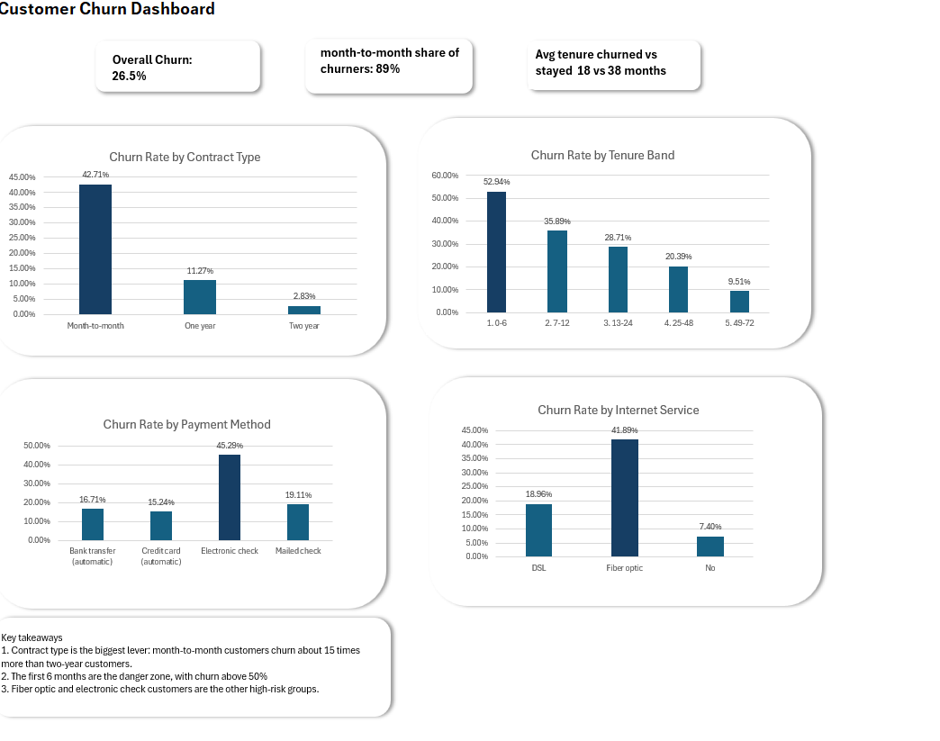
- Limitations
- The dataset has no sign-up dates, so cohorts are based on tenure bands rather than sign up month.\There are no cancellation reasons, so the reasons for churn are inferred from patters in the data.
- The figures show relationships between customer groups and churn. They do not prove that changing one factor will cause churn to fall.

